Action Items From The Central Florida Community Gardens Collaborative Gathering - April 16. 2016

Twelve members representing 5 community gardens attended the luncheon/workshop held at the University Area CDC Complex along with Lisa Meredith from the UF Extension Office. The coalition of Community Gardens is formed to provide support to local community gardens and to promote the establishment of additional community gardens.

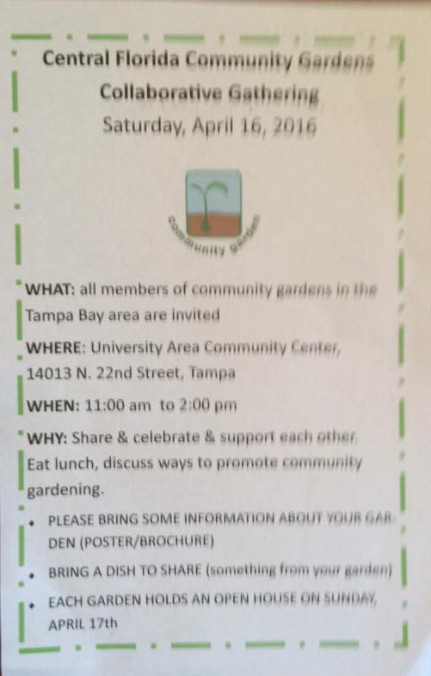

Here is the list of action items that this group would like to work on together.
Education & Data Collection:
- Look for opportunities to provide education on how to grow more community gardens in our area. Also education on food sources.
- Set up tables at Farmers Markets and various community events to educate the public on community gardens.
- Ask university students to man table and collect data on people who are interested in community gardening.
- Create a brochure detailing the community gardens in our area that can be available at the demonstration garden at the fair grounds and at the extension office.
- Connect with Susan at the Bok Tower in Polk County through Lisa of the Extension Office
- Learn more about the Florida Food Policy Council and connect with them.
- Community garden members can fill an application and offer to teach classes at HCC in the Continuing Education Department.
- Hold regular meetings, quarterly, to gather community garden groups like this luncheon to help encourage, motivate and support these gardens: NEXT MEETING IS JULY 23 AT THE EXTENSION OFFICE; OCTOBER MEETING – INVITED TO TAMPA HTS COMMUNITY GARDEN. TENTATIVELY OCT. 22.
- Create organization that can work on behalf of our coalition of community gardens.
- Each garden identify the needs of the other garden and schedule volunteer help for the gardens including bringing in the universities and community colleges
- Plant City Community Garden is located on HCC Campus, partners with Lincoln Elementary School in Plant City; encourage these partnerships
- Plant City Community Garden really wants to get connected on the Green ARTery trail. Karen will speak to the Mayor of Plant City to ask for his help to have this happen
- Promote school gardens:
  - Lisa from the Extension Office is providing training in some elementary schools and will have a training at the Florida Fair Grounds that will include home schooled students – She needs help with this education of students – not enough staff to do more
  - Wants to offer curriculum and workshops for teachers in schools on community gardening but also provide support staff to help with gardening and teaching in the schools to help link gardens to schools
- Suggest that each garden on a school site to offer community service for high-schoolers and offer Kids Day at the gardens
- Suggest that each community garden offer community service for high-schoolers.
- Suggest that all gardens become members of the facebook page established for the Coalition of Community Gardens:
  - https://www.facebook.com/communitygardencoalition12345/
Growing Gardens:
- Set the goal to grow more community gardens
- Make the Pinellas/Hillsborough Counties connection
- Institute a policy that Every time a new road is built it MUST include an area for community gardening
- Work to have community gardens at every park and recreation center
- Creating new gardens/attractions in many forms. Eg. Install Holiday Light Shows at gardens for Christmas, botanical gardens, weddings sites, walking garden tours, open house and plant sales
- Create a site for dumping leaves for composting
Extending Knowledge and Learning From Other Sources:
- Take a few road trips to see how community gardening is operating in other locations, including those that Dr. Elizabeth Strom’s classes have studied in association with MOPs
- Arrange a food desert conference and gardening education early in 2017
- Start arranging Garden Tours in the area
- Create a destination card for visitors and residents highlighting all community gardens and their locations in the area
- Plant City would like to be a central hub for some of these events. They have a lot of space
- Lisa will send the report from Joseph English, the doctoral student who did research last year on community gardens

*****************************************************************

